Advanced Object-Oriented Design and Programming July 2026 Advanced Object-
Individual Coding Exercise

Introduction
This report describes a banking system, written in Python, that allows several users to deposit, withdraw, transfer and check balances at the same time without corrupting the account data. The system is built from five source files and is supported by 19 unit tests.
Three problems had to be solved. First, a race condition: if two threads change the same balance at once, one update can be silently lost. Second, deadlock: transfers need two locks at once, and two transfers running in opposite directions can block each other for ever. Third, data integrity: no user should ever see a balance that is half-way through a transaction. The sections below explain the design chosen, show the code that implements it, and present the testing that validates it.

Design choices

Class structure
Account (abstract, ABC)
─────────────────────────
- _account_number
- _owner
- _balance
- _lock (threading.RLock)
- _history
─────────────────────────
+ deposit(amount)
+ withdraw(amount)
+ get_balance()
+ get_transaction_history()
# _available_funds() <- abstract
│
│ inherits
▼
BankAccount
(no overdraft allowed)
│ │
┌──────────┘ └──────────┐
▼ ▼
SavingsAccount CurrentAccount
(keeps a minimum balance) (agreed overdraft limit)
+ add_interest()
Bank ──── has many ────► Account
─────────────────────────────────
+ open_account()
+ transfer(source, target, amount) <- ordered locking
+ total_balance()
TransactionSimulator ──── uses ────► Bank, Account
─────────────────────────────────────────────────────
+ run() <- starts one thread per simulated user

Files and responsibilities
File | Responsibility
bank_account.py | Validation, the abstract Account class and the three account types
bank.py | The Bank: holds accounts, performs transfers, totals balances
simulator.py | TransactionSimulator: runs many users on threads and checks the result
test_bank_system.py | 19 unit tests (test cases T01–T17)
main.py | Four demonstrations
deadlock_experiment.py | Evidence for the two locking decisions (Section 6.3)

Key decisions and reasons
Decision | Reason
Decimal for all money, never float | float cannot store decimal fractions exactly (0.1 + 0.2 = 0.30000000000000004), so balances would drift over thousands of transactions
One lock per account, not one global lock | Two customers using two different accounts should not have to wait for each other
threading.RLock rather than threading.Lock | transfer() holds an account lock and then calls withdraw(), which needs the same lock again (proved in Section 6.3)
Raise exceptions instead of returning False | A returned False can be ignored by the caller; an exception cannot be ignored by accident
Validate input before locking | One user's mistyped amount should not make every other thread wait

Object-oriented concepts applied

Abstraction
The Account is an abstract base class. To a caller, the matter is straightforward: one invokes deposit() and is not concerned with whether a lock has been put in place, the amount validated or a history record committed. The class takes care of all that behind the scenes.
class Account(ABC):
"""Abstract, thread-safe bank account."""
@abstractmethod
def _available_funds(self):
"""Return how much may be withdrawn from this account right now."""

Encapsulation
There are safeguards in place for the balance. Kept in the private _balance attribute, it is accessible only via the locked methods and a read-only property. This prevents any outside code from doing something like account.balance = 1000000 to get around the validation and the lock. For similar reasons a copy of the transaction history is what is returned.
@property
def account_number(self):
"""Unique identifier for this account (read-only)."""
return self._account_number
def get_transaction_history(self):
"""Return a COPY of the transaction history."""
with self._lock:
return list(self._history)

Inheritance
SavingsAccount and CurrentAccount both extend BankAccount. They reuse all the locking, validation and history code and add only what is different: a minimum balance and an interest method for savings, an overdraft limit for the current account.

Polymorphism
While the three account types make use of the same withdraw() method, they are subject to three distinct rules. This is because that method in turn calls _available_funds(), a function each subclass has put its own spin on.
class BankAccount(Account):
def _available_funds(self):
return self._balance # no overdraft
class SavingsAccount(BankAccount):
def _available_funds(self):
spendable = self._balance - self._minimum_balance
return spendable if spendable > 0 else Decimal("0.00")
class CurrentAccount(BankAccount):
def _available_funds(self):
return self._balance + self._overdraft_limit
One can see the results in Demonstration 1 of main.py. With an identical method call requesting 1100.00 from accounts with 1000.00 on hand:

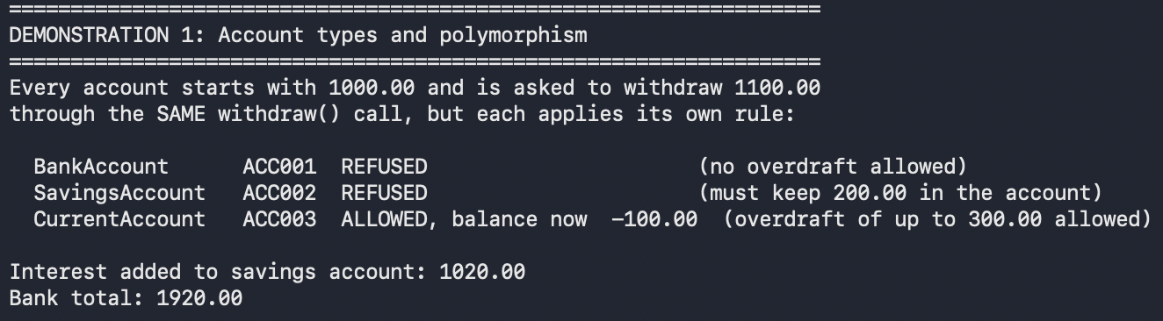

Design patterns used
The Template Method is at work in withdraw(). It sets the procedure for validating, checking and deducting funds, then recording it, and lets the subclass handle the one variable part, _available_funds(). Should a fourth product be added, there is nothing to change but the writing of a brief method.
Then there is the Facade pattern. Bank provides a straightforward interface for what is otherwise a complex operation. A simple bank.transfer(alice, bob, 250) is all the caller needs to do; there is no requirement to be aware of the sorting of accounts or the acquiring and releasing of two locks.

Concurrency and thread safety
Concurrency means managing several tasks over the same period of time. In this system each simulated user is a threading.Thread, and several threads share the same account objects.
Sharing data is what creates the danger. The statement balance = balance + amount looks like one action but is really three: read the balance, add the amount, write the result back. Python's Global Interpreter Lock does not prevent a thread switch between those steps, so two threads can both read 100, both compute their own new value, and one update is overwritten and lost.
The system prevents this by wrapping every operation that touches the balance in the account's own lock:
def withdraw(self, amount):
amount = validate_amount(amount)
with self._lock: # critical section starts
available = self._available_funds() # CHECK
if amount > available:
raise InsufficientFundsError(...)
self._balance -= amount # ACT
self._record("WITHDRAW", amount)
return self._balance # critical section ends
We keep the check and the deduction under one lock. Were they in two distinct locked blocks, you would have a “check-then-act” race on your hands: two threads might spot sufficient funds and each make a withdrawal, putting the account in overdrawn

Which locking mechanism, and why
Mechanism | What it does | Suitability here
threading.Lock (mutex) | One thread at a time; cannot be re-acquired by the holder | Rejected - transfer() self-deadlocks (Section 6.3, Experiment A)
threading.RLock (re-entrant mutex) | One thread at a time, but the owning thread may re-enter | Chosen - allows transfer() to hold the lock and still call withdraw()
threading.Semaphore | Allows N threads in at once | Unsuitable - a balance needs exactly one writer, so N = 1, which is just a mutex
Monitor (Condition) | A lock plus wait/notify signalling | Not needed - no operation has to wait for a state change; a withdrawal that cannot be funded is declined immediately

I have opted for a re-entrant mutual-exclusion lock, or threading.RLock, as the mechanism of choice. It is kept for the minimum duration and put under the control of a with block to ensure its release; in this way a rejected transaction will not be left with a strayed lock.

Evidence that the locking is necessary
One can see in Demonstration 2 of main.py how the same workload is put through its paces twice. Eight threads are made to deposit 1.00 on 250 occasions, first to an account that has no lock and then to a BankAccount.

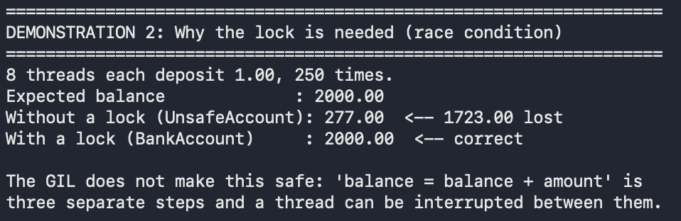
The race condition has wiped out some 87% of the deposits. Put the identical load through the locked class and the figure is exact without fail.

Deadlock prevention

Why a transfer is the dangerous operation

There is an inherent risk in performing a transfer. To be safe, the operation has to secure the locks on both accounts concurrently; fail to do so and a different thread may spot the funds in transit from source to target. But acquiring two locks at once opens the door to deadlock.

The problem and the solution
If each thread simply locked its own source account first:
Thread A: transfer(ACC001 -> ACC002) locks ACC001, waits for ACC002
Thread B: transfer(ACC002 -> ACC001) locks ACC002, waits for ACC001
Now neither can proceed and neither is going to let go of what they have. You have a circular wait, or as Coffman et al. (1971) put it, one of the four prerequisites for a deadlock.
To avoid this, we employ ordered locking. Before a lock is even attempted, the pair of accounts are put in order by number. That way the system is consistent, and each thread will invariably lock the lower number first.

def transfer(self, source, target, amount):
amount = validate_amount(amount) # validate before locking
if source.account_number == target.account_number:
raise ValueError("Cannot transfer to the same account.")
# This single line is the deadlock prevention: a fixed, global order.
first, second = sorted([source, target], key=lambda a: a.account_number)
with first.lock:
with second.lock:
source.withdraw(amount) # raises if funds are short
target.deposit(amount)
return True

As the above example shows, the two threads will both make a move to lock ACC001. Since only one can have it, the other has to stand by and wait; in this way the circle is precluded from forming. The same logic holds for total_balance(), so there is no risk of an audit of the bank’s total deadlocking with a transfer.

Experimental evidence
To put matters beyond question, deadlock_experiment.py has been provided with some intentionally flawed code so that the issues are seen in practice instead of just on paper. Here is what the program produces:
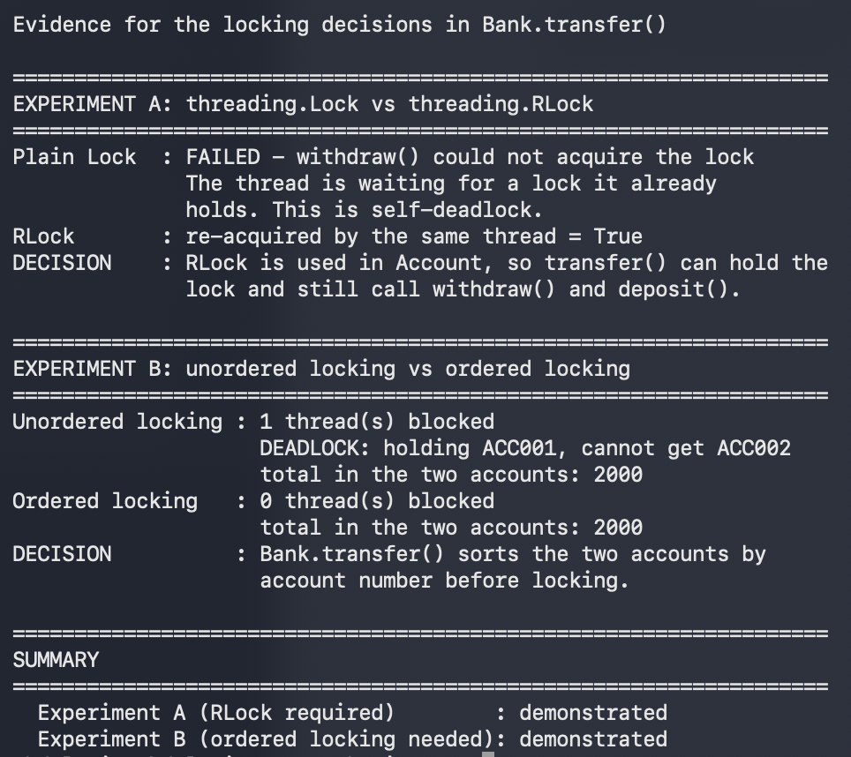
Both faults reproduce reliably, and both are removed by the design decisions described above.

Testing and validation
Tests were written with the unittest framework. Every test method carries its test-case number, so each row of the table below can be traced to the code that produced it. All 19 tests pass; the suite runs in under a second.
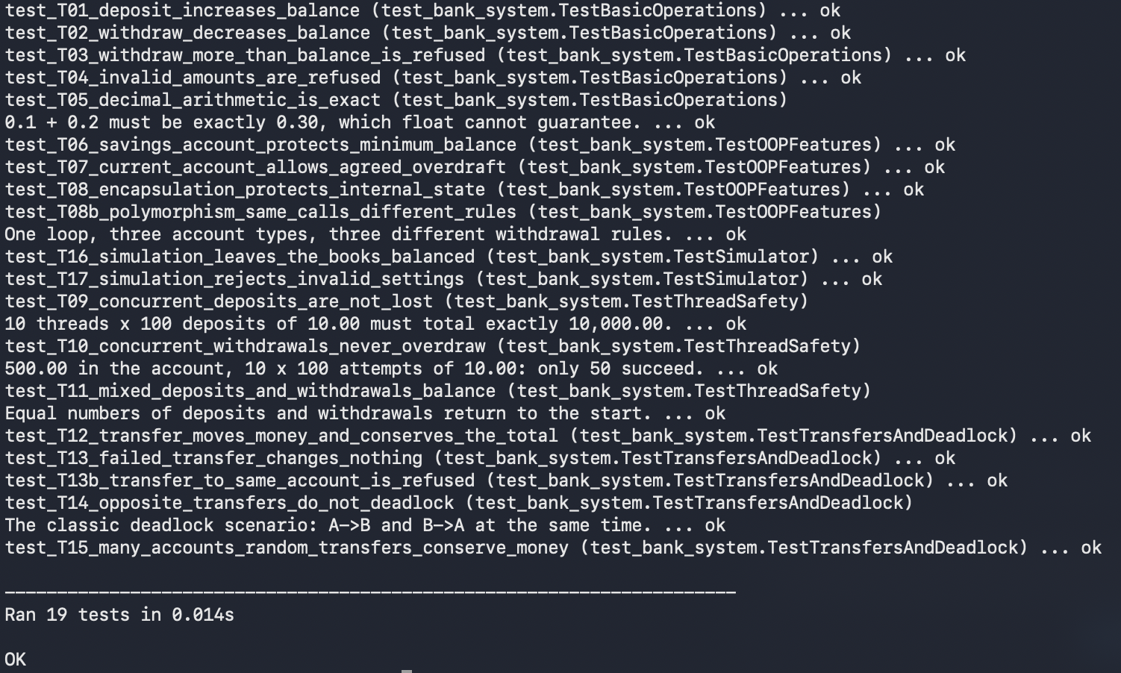

Conclusion
In a practical banking context, the system puts to use the principles of abstraction, encapsulation, inheritance and polymorphism. To ensure concurrent access is handled with safety, it employs per-account re-entrant locks alongside a global ordering for any transfers; these were put to the test by reproducing the very faults they are meant to stop. The integrity of balances after concurrent transactions is borne out by four demonstrations and a suite of 19 unit tests.

References
Python Software Foundation (2026) threading - Thread-based parallelism. Available at: https://docs.python.org/3/library/threading.html (Accessed: 5 September 2026). Consulted for RLock re-entrancy semantics.
Python Software Foundation (2026) decimal - Decimal fixed point and floating point arithmetic. Available at: https://docs.python.org/3/library/decimal.html (Accessed: 5 September 2026).
Coffman, E.G., Elphick, M. and Shoshani, A. (1971) 'System Deadlocks', ACM Computing Surveys, 3(2), pp. 67–78. Source of the circular-wait condition cited in Section 6.2.
Van Rossum, G., Warsaw, B. and Coghlan, N. (2001) PEP 8 - Style Guide for Python Code. Available at: https://peps.python.org/pep-0008/ (Accessed: 5 September 2026).

Appendix A - How to run
python main.py # four demonstrations
python -m unittest test_bank_system.py -v # the 19 unit tests
python deadlock_experiment.py # locking evidence

Appendix B - Full source code
The complete source is submitted alongside this report: bank_account.py, bank.py, simulator.py, test_bank_system.py, main.py and deadlock_experiment.py.

